**Description: OC_Masterbrand_CMYK.eps**

in partnership with

****

ICT40515 Certificate IV in Programming

Develop a UI to interact with a database

**SP6/Module 9 Assessment**

ICTPRG403 Develop data-driven applications

ICTICT420 Develop client user interface

ICTPRG410 Build a user interface

Assessment: 33130/03

*© Open Colleges Pty Ltd, 2016*

*All rights reserved. No part of the material protected by this copyright may be reproduced or utilised in any form or by any means, electronic or mechanical, including photocopying, recording, or by any information storage and retrieval system, without permission in writing from the copyright owner.*

*All terms mentioned in this text that are known to be trademarks or service marks have been appropriately capitalised. Use of a term in this text should not be regarded as affecting the validity of any trademark or service mark.*

**Assessment task 33130/02**

## Introduction

This assessment will test your skills and knowledge gained through completing the learning and activities in **Module 9: Develop a UI to interact with a database.**

This is a three-part assessment.

In the first part of the assessment, you will analyse a requirements brief to design and develop user interfaces for a number of screens.

In the second part, you will write code for the screens developed in the first part of the assessment to connect and interact with a database.

In the third part of the assessment, you will answer a number of questions, which will test your knowledge on developing and building a user interface, and developing a data driven application.

**Note – you must successfully complete ALL assessments (33130/01, 33130/02 and 33130/03) to achieve competency in:**

***ICTPRG403 Develop data-driven applications***

***ICTICT420 Develop client user interface***

***ICTPRG410 Build a user interface***

**Short answer questionnaire**

Answer each of the twelve (12) questions. Do not write more than 100 words for each question.

Rename this document to: StudentNumber\_UIDB\_33130-03.docx. For example, 665437\_UIDB\_33130-03.docx.

Provide answers in the space under each question.

1. Detail considerations of UI design regarding batch procedures.

Answer: A batch interface is generally a non-interactive user interface, where the operator will specify the details of the specific batch job to execute in advance and then the user interface will display the output when all batch processes are done. The user interface generally will not prompt the user for further input once the batch process has started as generally batch processes are conducted together for a reason and interrupting that could case data loss or unwanted side effects.

1. Research and discuss current industry design principles including GUI and web design.

Answer: This is a very broad topic, in which many users will have differing opinions on the current industry design principles but after some research I was able to find some that were mentioned in almost all areas.

Firstly the GUI especially for web design must be intuitive. Unlike a program in which some one may have bought and therefore will take the time to learn, A website is generally accessed for free and if it is hard to navigate the user they are likely to leave the site before learning how to use it. In short the user should know how to use the GUI as soon as it loads.

Secondly some form of consistency / style guide lines should be used. Fonts, imagery, colour’s and layout should be consistant through the application or website to ensure the user feels comfortable whilst using it.

Lastly keep everything simple. There is no need to over complicate the design, all it will do is confuse the user and they will most likely not use the interface anymore. Forms should be clear in exactly what needs to be filled out, error messages should be clear in what went wrong and how they can fix the problem.

In closing the GUI for anything should make the user feel happy whilst using it.

1. Research and identify general features and capabilities of current industry-accepted hardware and software products and user interfaces.

Answer: A very good example of all three areas being hardware, software and user interface is Virtual Reality (VR). VR is a fairly new technology that cannot just be worked on from a software point of view like many other products. Any good VR packages will include hardware, which in generally a specifically designed head set with glasses and software to support it. In terms of UI it must be designed with a lot of thought and testing because many trials of VR have concluded that certain UI’s make the user feel sick in particular motion sickness. All three areas of the technology being the hardware, the software and the UI are being developed and tested in tandem with each other.

1. Describe a multi-layer application and identify the layers.

Answer: A multi-layer application is one that aims to separate different areas of development to make developing the code easier. A basic multi-layer application is made up of three layers. The Presentation layer, in which contains all the GUI the end user will user and the code that connects one form to another for example. The business logic layer, which helps to coordinate the application, process commands, make logical decisions and evaluations. It is also responsible for moving data between the presentation layer and the Data layer. It will generally contain classes and methods to help achieve this. Finally, the Data Layer is the layer which has to code to extract data from the database. IT is generally passed through the business logic layer and into the presentation layer.

1. Research and describe disconnected data management strategy.

Answer: Disconnected data manage is in simple terms the process of still using a database whilst not being connected to the database. This has a number of useful applications in the real world. One example is for a travelling salesman, they can update their phone with the latest customer information at the beginning of the day, then they can view all the relevant tables during their travels away from the office and then at the end of the day they and sync their database back up with the one in the office. Another example is one that I used in the module 9 project. On the main customers page I read the data from the table using the database however then the connection is closed. When I go to update the customer entry Instead of pulling all the information from the database again and filling in the form I just take the information that is currently displayed in the table and fill in the fields using that. Then only when the user is ready to update I finally send a single update Query to the server and that is executed. The need for this type of disconnected data is huge in that it makes websites and businesses more scalable and more stream line, it also cuts down on server stress from many unnecessary calls being made to it.

1. Describe the features of object-oriented design and multi-layer applications.

Answer: The key features of object-oriented design and multi-layer applications are:

1. It keeps everything very separated and allows for scaling up or down of the application. Since no area of code really effects another area and especially the layers only interact with each other it means that only small areas of code need to be adjusted to have the overall effect the programmer was after.
2. Everything is named with consistency and therefore can be accessed easily from other layers just using the name given in that class.
3. Object orientated design means that some classes will inherit properties from other classes which also cuts down code and makes it more readable.
4. Provide an outline of relational database management systems.

Answer: A relational database management system is a program that lets you create, update, delete and administer a relational database. Almost all of the RDBMS’s use Structured Query Language (SQL) to access the database. The most popular RDBMS’s are Microsoft SQL Server, Oracle and DB2 and MySQL. They are all based on the relational database model as seen below:

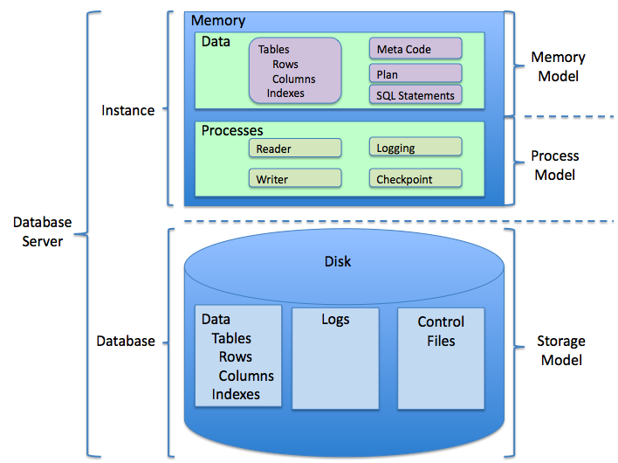

1. Describe object-oriented programming at an intermediate level.

Answer: Object Orientated Programming is a type of programming that is based on a hierarchy of classes and Objects. A class defines the data and how the methods will interact with the data. An object is an instance of a class. The reason this is so powerful is that you can have many objects from the same class. Inheritance is an OOP concept that allows objects to work together. It is the relationship between the classes. From inheritance, you get super classes and sub classes. Subclasses generally inherit all properties from their super class however the super class inherits none of the properties of their subclasses. Polymorphism is a way to define a method so that it can take objects are parameters. It describes a pattern in OOP in which classes have differing functionality whilst sharing a common interface.

1. Outline the principles of a Structured Query Language (SQL)

Answer: There are four basics principles of SQL.

Atomicity: All code flows without the need to update or fix data.

Consistency: All SQL statements are either execute 100% or fail 100%. Code that allows part of an SQL statement to run whilst failing in another area can cause serious issues to the database.

Isolation: Data and logs should be kept away from the public. Only a limited number of users should have access to the database, and a ranking structure should be used (roles) to determine how much access each person actually has over the database.

Durability: The servers should have enough storage and processing power to complete the task it was meant to achieve. Also regular database backups should be kept in a separate location. Also all transactions should be executed immediately with no backlog to prevent data corruption.

1. Name an open source Integrated Development Environment (IDE) that you have used and how you used it.

Answer: An open source IDE that I personally have used is called Brackets, On the surface it operates pretty much like a basic text editor but once you learn the controls and apply some packages to it, it becomes a very powerful development tool. I have mainly used this IDE whilst making web pages or writing various python scripts.

One of the packages I personally use is called Emmet. It is an auto complete / short hand package that lets you develop large amounts of needed code without lots of unnecessary typing.

1. Describe the process of developing small-size applications.

Answer: There are many different ways to develop small sized applications and it is really up to the programmers and users discretion which should be used. I personally use the Waterfall Model when designing small applications as they are usually straight forward and require very little adjustment of the original requirements. This methodology has 5 stages,

1. Outline the requirements.
2. Design the software.
3. Implement the software in its environment.
4. Verify everything is working.
5. Maintain the program through the course of its life.

In all honesty, sometimes a mix of agile / waterfall methodologies can be good though as some parts of the program might require additional features to be added whilst some other areas are far more stream line.

1. Explain the function of the Data Access Layer (DAL) in a multi-layer application. Name two data-access application programming interfaces(API) for connecting to a database and how you would determine which API to use.

Answer: The purpose of the Data Access Layer (DAL) in a multi-layer application is to keep the code you use to pull data from the database separate to the business logic layer and presentation layer. This not only makes everything look much neater but it also means the code is easier to maintain, because you know that everything to do with pulling data from the database is in that one area.

One very commonly used API is Object Relational Mapping aka (ORM). ORM essentially converts data between two incompatible type systems in OOP languages. This in effect will give the programmer a virtual object database to work with and can cut down coding time significantly.

Another type of Database API is Drupal 7. It is mainly used with php applications so that would be the main reason for using Drupal 7 over a different API.

To choose which API is best for the application a number of considerations need to be taken into account. How many people are working on the project, do they all have the knowledge to use the proposed API? Which API is recommended to use with the programming language the base application is being coded in. Will the application need to be scalable at a future date or is this a one off project that will not need to be adjusted. Once you ask yourself these questions then you can decide which API is best suited for the project and choose from the shortlist you have.

References:

<http://etutorials.org/SQL/SQL+Bible+Oracle/Part+I+SQL+Basic+Concepts+and+Principles/>

https://stackoverflow.com/questions/1031273/what-is-polymorphism-what-is-it-for-and-how-is-it-used

<http://manusqlinfo.blogspot.com.au/2007/08/four-principles-of-database-design.html>

http://csharp-station.com/Tutorial/AdoDotNet/Lesson05

https://pdfs.semanticscholar.org/8152/3b68af22b67d7d230985d38f51bb34f65fe7.pdf

**Next steps for you:**

You have now reached the end of this assessment.

Ensure that you have answered all of the above questions.

Upload this document to OpenSpace. Label your file your StudentNumber\_UIDB\_33130-03.docx. E.g. 665437\_UIDB\_33130-03.docx.

Your trainer will provide you with feedback for this assessment.